Documentación De las Capturas del Laboratorio UDP

Validación del “./gradlew test” para así ver si el Proyecto Compila correctamente:
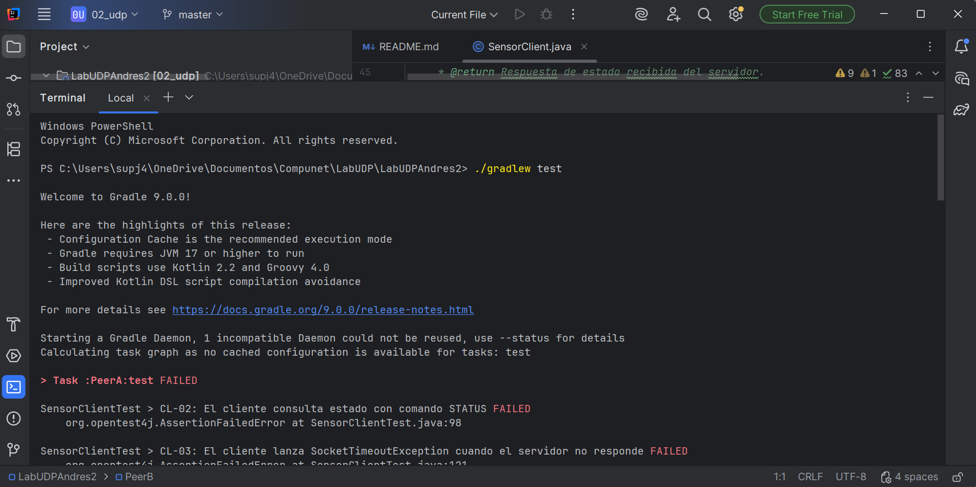

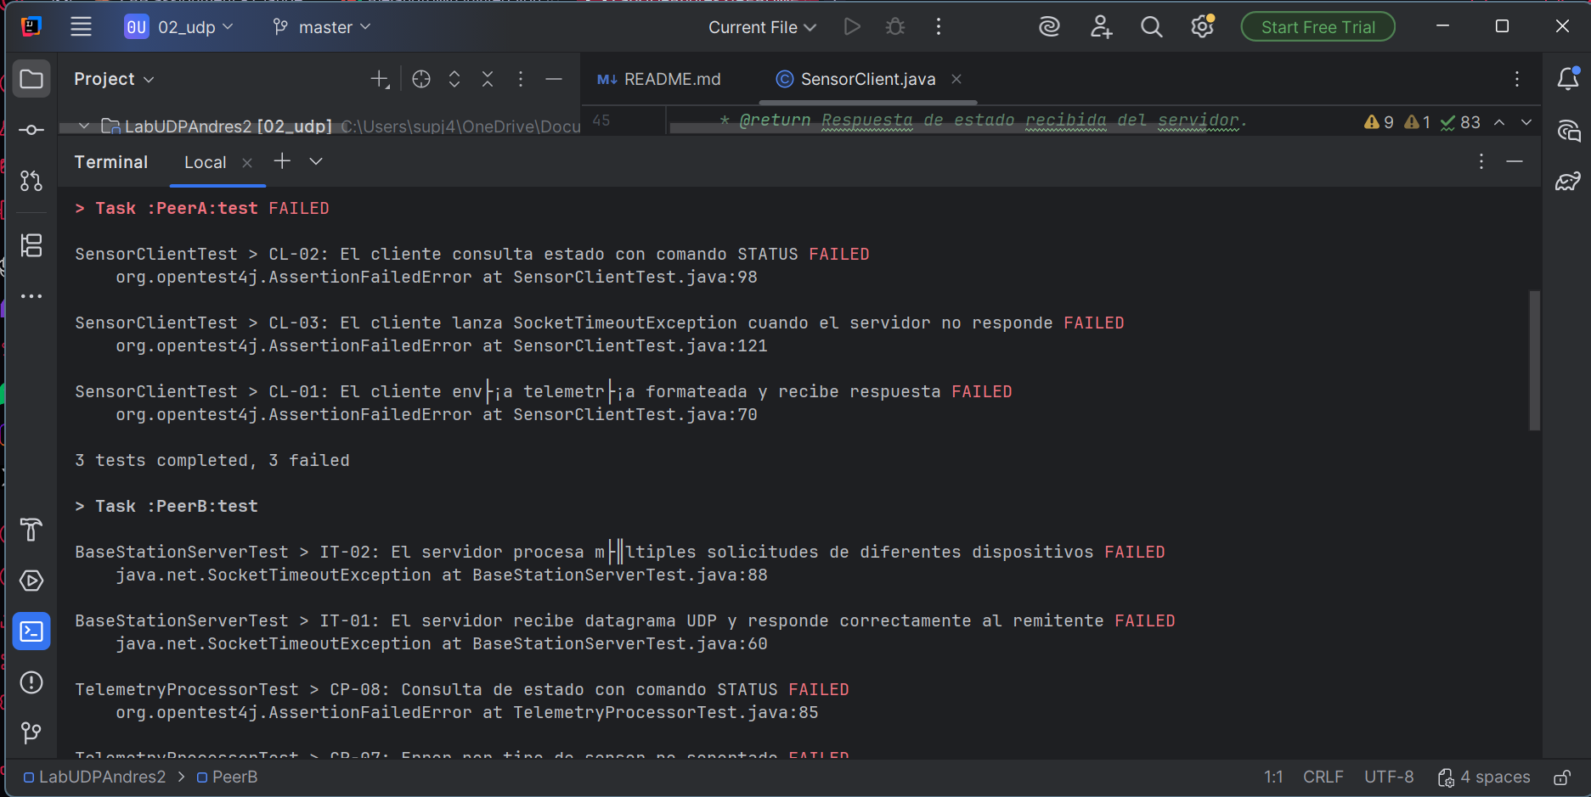

Texto o Aviso de la terminal
PS C:\Users\supj4\OneDrive\Documentos\Compunet\LabUDP\LabUDPAndres2> ./gradlew test

Welcome to Gradle 9.0.0!

Here are the highlights of this release:
- Configuration Cache is the recommended execution mode
- Gradle requires JVM 17 or higher to run
- Build scripts use Kotlin 2.2 and Groovy 4.0
- Improved Kotlin DSL script compilation avoidance

For more details see https://docs.gradle.org/9.0.0/release-notes.html

Starting a Gradle Daemon, 1 incompatible Daemon could not be reused, use --status for details
Calculating task graph as no cached configuration is available for tasks: test

> Task :PeerA:test FAILED

SensorClientTest > CL-02: El cliente consulta estado con comando STATUS FAILED
org.opentest4j.AssertionFailedError at SensorClientTest.java:98

SensorClientTest > CL-03: El cliente lanza SocketTimeoutException cuando el servidor no responde FAILED
org.opentest4j.AssertionFailedError at SensorClientTest.java:121

SensorClientTest > CL-01: El cliente env├¡a telemetr├¡a formateada y recibe respuesta FAILED
org.opentest4j.AssertionFailedError at SensorClientTest.java:70

3 tests completed, 3 failed

> Task :PeerB:test

BaseStationServerTest > IT-02: El servidor procesa m├║ltiples solicitudes de diferentes dispositivos FAILED
java.net.SocketTimeoutException at BaseStationServerTest.java:88

BaseStationServerTest > IT-01: El servidor recibe datagrama UDP y responde correctamente al remitente FAILED
java.net.SocketTimeoutException at BaseStationServerTest.java:60

TelemetryProcessorTest > CP-08: Consulta de estado con comando STATUS FAILED
org.opentest4j.AssertionFailedError at TelemetryProcessorTest.java:85

TelemetryProcessorTest > CP-07: Error por tipo de sensor no soportado FAILED
org.opentest4j.AssertionFailedError at TelemetryProcessorTest.java:78

TelemetryProcessorTest > CP-02: Alerta de temperatura alta (> 40.0) FAILED
org.opentest4j.AssertionFailedError at TelemetryProcessorTest.java:29

TelemetryProcessorTest > CP-03: Alerta de congelamiento / temperatura bajo cero (< 0.0) FAILED
org.opentest4j.AssertionFailedError at TelemetryProcessorTest.java:36

TelemetryProcessorTest > CP-05: Registro y alertas de bater├¡a FAILED
org.opentest4j.AssertionFailedError at TelemetryProcessorTest.java:56

TelemetryProcessorTest > CP-01: Registro de temperatura en rango normal FAILED
org.opentest4j.AssertionFailedError at TelemetryProcessorTest.java:22

TelemetryProcessorTest > CP-04: Registro y alertas de humedad FAILED
org.opentest4j.AssertionFailedError at TelemetryProcessorTest.java:43

TelemetryProcessorTest > CP-06: Manejo de formatos inv├ílidos y errores de parseo FAILED
org.opentest4j.AssertionFailedError at TelemetryProcessorTest.java:65

10 tests completed, 10 failed

> Task :PeerB:test FAILED

FAILURE: Build completed with 2 failures.

1: Task failed with an exception.
-----------
* What went wrong:
Execution failed for task ':PeerA:test'.
> There were failing tests. See the report at: file:///C:/Users/supj4/OneDrive/Documentos/Compunet/LabUDP/LabUDPAndres2/PeerA/build/reports/tests/test/index.html

* Try:
> Run with --scan to generate a Build Scan (Powered by Develocity).
==============================================================================

2: Task failed with an exception.
-----------
* What went wrong:
Execution failed for task ':PeerB:test'.
> There were failing tests. See the report at: file:///C:/Users/supj4/OneDrive/Documentos/Compunet/LabUDP/LabUDPAndres2/PeerB/build/reports/tests/test/index.html

* Try:
> Run with --scan to generate a Build Scan (Powered by Develocity).
==============================================================================

BUILD FAILED in 21s
6 actionable tasks: 6 executed
Configuration cache entry stored

Se puede apreciar que fallan muchas pruebas vamos a ir poniendo en verde cada una; pero primero haremos el primer paso

Paso 1:
Primero verificaremos las pruebas de solo esa clase o paso para ver si si pasan sus Tests, con el comando “./gradlew :PeerB:test --tests "service.TelemetryProcessorTest”
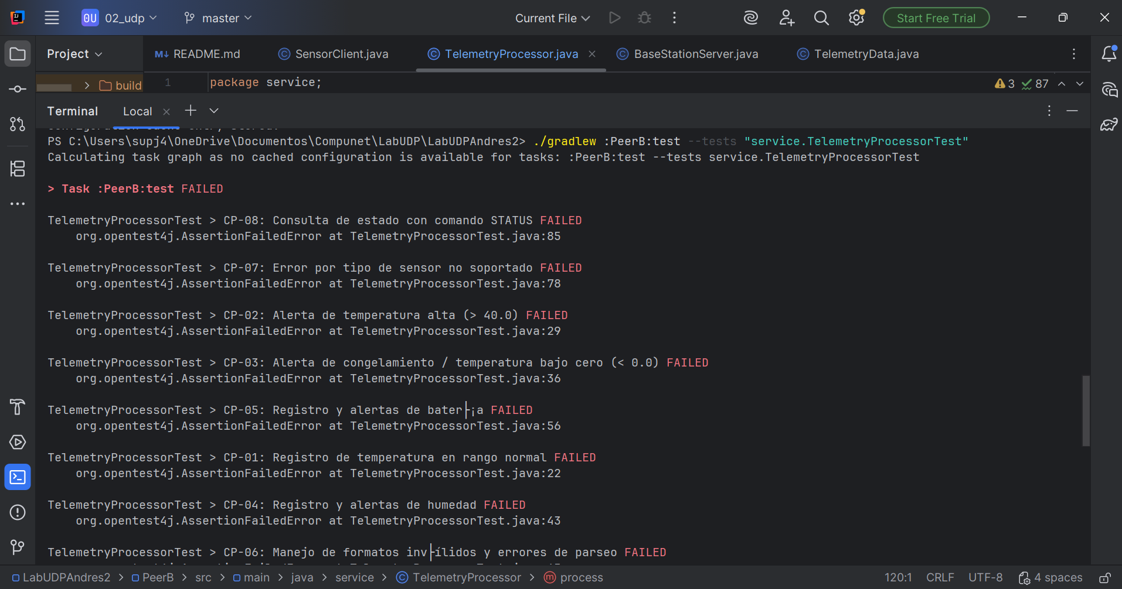
No pasan; a continuación, su salida de la terminal:
PS C:\Users\supj4\OneDrive\Documentos\Compunet\LabUDP\LabUDPAndres2> ./gradlew :PeerB:test --tests "service.TelemetryProcessorTest"
Calculating task graph as no cached configuration is available for tasks: :PeerB:test --tests service.TelemetryProcessorTest

> Task :PeerB:test FAILED

TelemetryProcessorTest > CP-08: Consulta de estado con comando STATUS FAILED
org.opentest4j.AssertionFailedError at TelemetryProcessorTest.java:85

TelemetryProcessorTest > CP-07: Error por tipo de sensor no soportado FAILED
org.opentest4j.AssertionFailedError at TelemetryProcessorTest.java:78

TelemetryProcessorTest > CP-02: Alerta de temperatura alta (> 40.0) FAILED
org.opentest4j.AssertionFailedError at TelemetryProcessorTest.java:29

TelemetryProcessorTest > CP-03: Alerta de congelamiento / temperatura bajo cero (< 0.0) FAILED
org.opentest4j.AssertionFailedError at TelemetryProcessorTest.java:36

TelemetryProcessorTest > CP-05: Registro y alertas de bater├¡a FAILED
org.opentest4j.AssertionFailedError at TelemetryProcessorTest.java:56

TelemetryProcessorTest > CP-01: Registro de temperatura en rango normal FAILED
org.opentest4j.AssertionFailedError at TelemetryProcessorTest.java:22

TelemetryProcessorTest > CP-04: Registro y alertas de humedad FAILED
org.opentest4j.AssertionFailedError at TelemetryProcessorTest.java:43

TelemetryProcessorTest > CP-06: Manejo de formatos inv├ílidos y errores de parseo FAILED
org.opentest4j.AssertionFailedError at TelemetryProcessorTest.java:65

8 tests completed, 8 failed

FAILURE: Build failed with an exception.

* What went wrong:
Execution failed for task ':PeerB:test'.
> There were failing tests. See the report at: file:///C:/Users/supj4/OneDrive/Documentos/Compunet/LabUDP/LabUDPAndres2/PeerB/build/reports/tests/test/index.html

* Try:
> Run with --scan to generate a Build Scan (Powered by Develocity).

BUILD FAILED in 3s
3 actionable tasks: 1 executed, 2 up-to-date
Configuration cache entry stored.

Después de la implementación guiada por los comentarios en el código, volví a correr esas pruebas de este paso de TelemetryProcessor
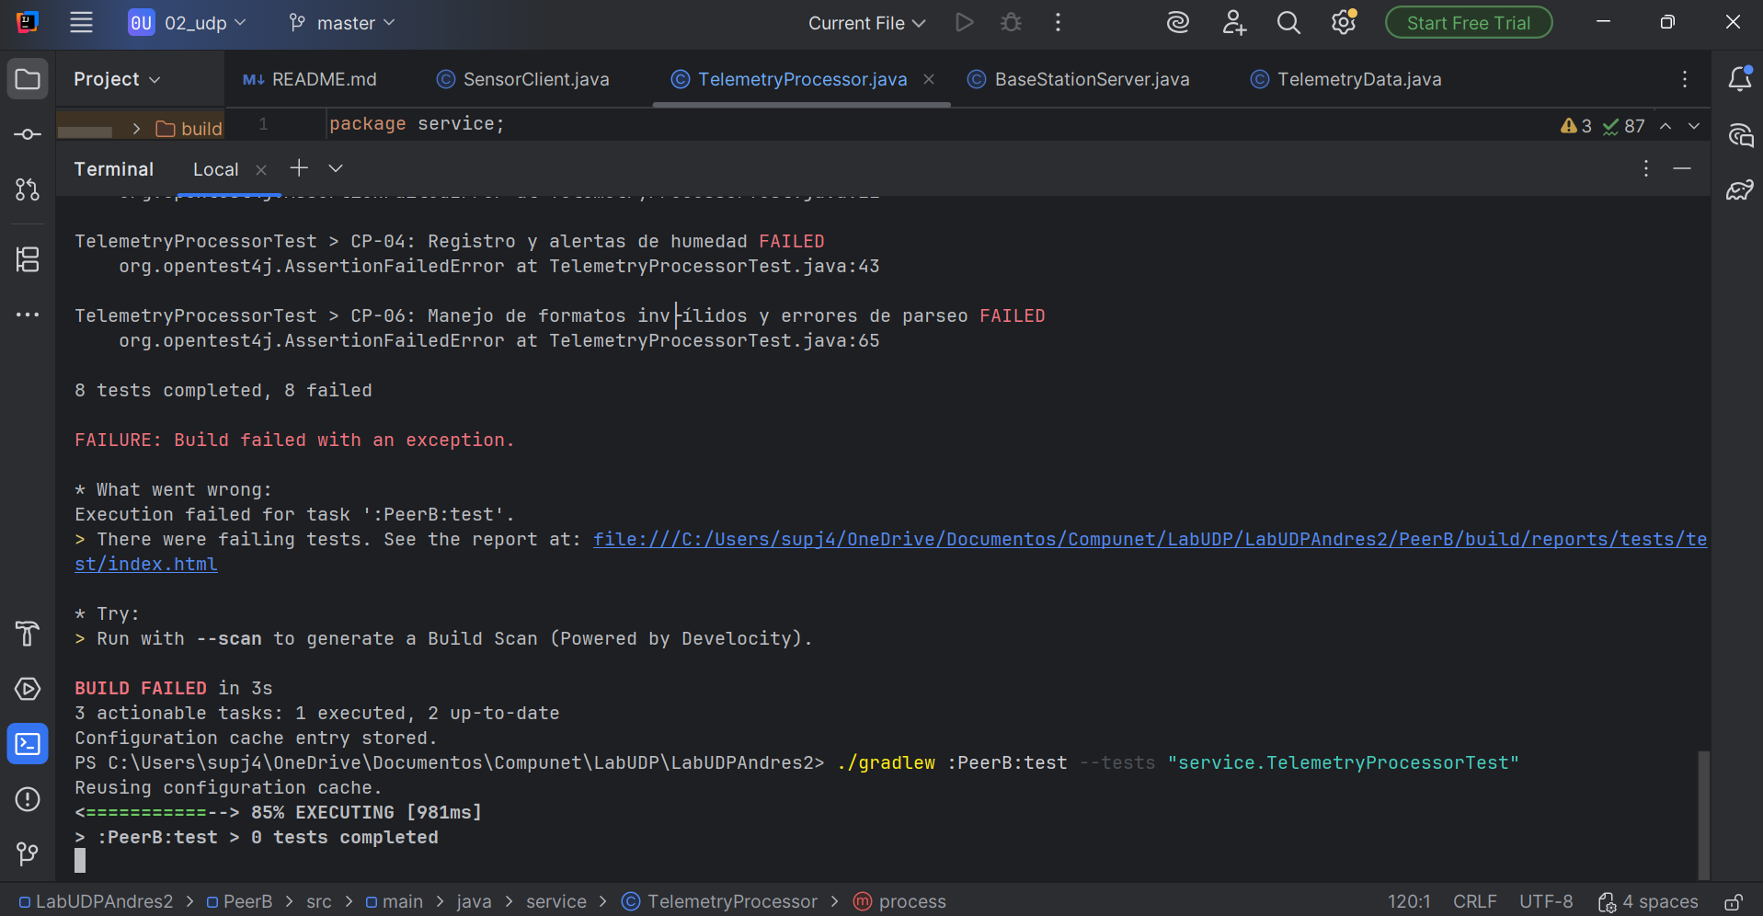

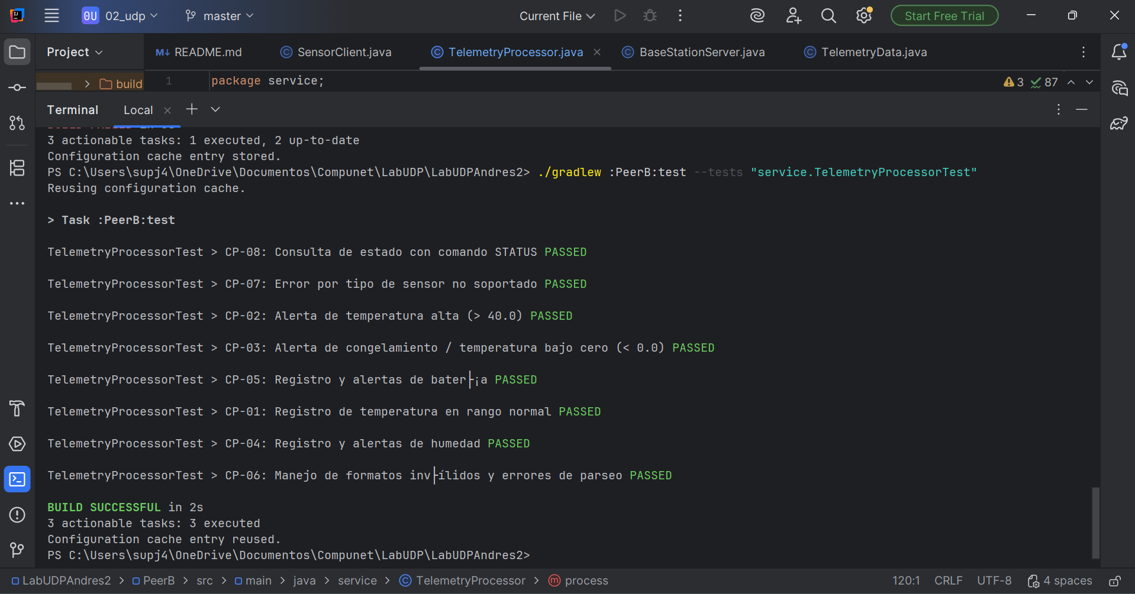

Paso 2:
Primero hacemos la comprobación antes de programar, con ./gradlew :PeerB:test --tests "service.BaseStationServerTest":
PS C:\Users\supj4\OneDrive\Documentos\Compunet\LabUDP\LabUDPAndres2> ./gradlew :PeerB:test --tests "service.BaseStationServerTest"
Calculating task graph as no cached configuration is available for tasks: :PeerB:test --tests service.BaseStationServerTest

> Task :PeerB:test

BaseStationServerTest > IT-02: El servidor procesa m├║ltiples solicitudes de diferentes dispositivos FAILED
java.net.SocketTimeoutException at BaseStationServerTest.java:88

BaseStationServerTest > IT-01: El servidor recibe datagrama UDP y responde correctamente al remitente FAILED
java.net.SocketTimeoutException at BaseStationServerTest.java:60

2 tests completed, 2 failed

> Task :PeerB:test FAILED

FAILURE: Build failed with an exception.

* What went wrong:
Execution failed for task ':PeerB:test'.
> There were failing tests. See the report at: file:///C:/Users/supj4/OneDrive/Documentos/Compunet/LabUDP/LabUDPAndres2/PeerB/build/reports/tests/test/index.html

* Try:
> Run with --scan to generate a Build Scan (Powered by Develocity).

BUILD FAILED in 8s
3 actionable tasks: 2 executed, 1 up-to-date
Configuration cache entry stored.

Ahora el resultado de la terminal después de la programación:

PS C:\Users\supj4\OneDrive\Documentos\Compunet\LabUDP\LabUDPAndres2> ./gradlew :PeerB:test --tests "service.BaseStationServerTest"
Reusing configuration cache.

> Task :PeerB:test

BaseStationServerTest > IT-02: El servidor procesa m├║ltiples solicitudes de diferentes dispositivos PASSED

BaseStationServerTest > IT-01: El servidor recibe datagrama UDP y responde correctamente al remitente PASSED

BUILD SUCCESSFUL in 2s
3 actionable tasks: 2 executed, 1 up-to-date
Configuration cache entry reused.
PS C:\Users\supj4\OneDrive\Documentos\Compunet\LabUDP\LabUDPAndres2>

PASO 3:
Comprobamos o verificamos que no pasan las pruebas antes de programar con ./gradlew :PeerA:test :
PS C:\Users\supj4\OneDrive\Documentos\Compunet\LabUDP\LabUDPAndres2> ./gradlew :PeerA:test
Calculating task graph as no cached configuration is available for tasks: :PeerA:test

> Task :PeerA:test FAILED

SensorClientTest > CL-02: El cliente consulta estado con comando STATUS FAILED
org.opentest4j.AssertionFailedError at SensorClientTest.java:98

SensorClientTest > CL-03: El cliente lanza SocketTimeoutException cuando el servidor no responde FAILED
org.opentest4j.AssertionFailedError at SensorClientTest.java:121

SensorClientTest > CL-01: El cliente env├¡a telemetr├¡a formateada y recibe respuesta FAILED
org.opentest4j.AssertionFailedError at SensorClientTest.java:70

3 tests completed, 3 failed

FAILURE: Build failed with an exception.

* What went wrong:
Execution failed for task ':PeerA:test'.
> There were failing tests. See the report at: file:///C:/Users/supj4/OneDrive/Documentos/Compunet/LabUDP/LabUDPAndres2/PeerA/build/reports/tests/test/index.html

* Try:
> Run with --scan to generate a Build Scan (Powered by Develocity).

BUILD FAILED in 2s
3 actionable tasks: 1 executed, 2 up-to-date
Configuration cache entry stored.

Ahora la terminal después de programar lo correspondiente en el Paso 3:
PS C:\Users\supj4\OneDrive\Documentos\Compunet\LabUDP\LabUDPAndres2> ./gradlew :PeerA:test
Reusing configuration cache.

> Task :PeerA:test

SensorClientTest > CL-02: El cliente consulta estado con comando STATUS PASSED

SensorClientTest > CL-03: El cliente lanza SocketTimeoutException cuando el servidor no responde PASSED

SensorClientTest > CL-01: El cliente env├¡a telemetr├¡a formateada y recibe respuesta PASSED

BUILD SUCCESSFUL in 3s
3 actionable tasks: 2 executed, 1 up-to-date
Configuration cache entry reused.

PASO 4 VERIFICACION INTEGRAL:

Como hicimos al inicio con el “./gradlew test”, que nos dio 13 Tests fallidos ahora nos debe de dar 13 Tests Exitosos:

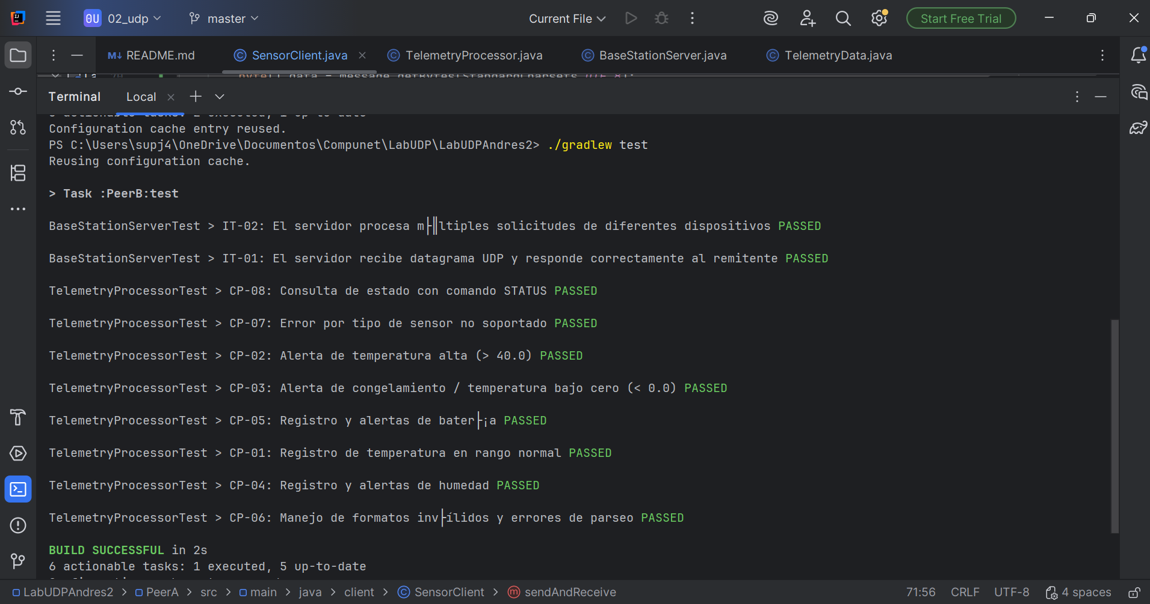

PS C:\Users\supj4\OneDrive\Documentos\Compunet\LabUDP\LabUDPAndres2> ./gradlew :PeerA:test
Reusing configuration cache.

> Task :PeerA:test

SensorClientTest > CL-02: El cliente consulta estado con comando STATUS PASSED

SensorClientTest > CL-03: El cliente lanza SocketTimeoutException cuando el servidor no responde PASSED

SensorClientTest > CL-01: El cliente env├¡a telemetr├¡a formateada y recibe respuesta PASSED

BUILD SUCCESSFUL in 3s
3 actionable tasks: 2 executed, 1 up-to-date
Configuration cache entry reused.
PS C:\Users\supj4\OneDrive\Documentos\Compunet\LabUDP\LabUDPAndres2> ./gradlew test
Reusing configuration cache.

> Task :PeerB:test

BaseStationServerTest > IT-02: El servidor procesa m├║ltiples solicitudes de diferentes dispositivos PASSED

BaseStationServerTest > IT-01: El servidor recibe datagrama UDP y responde correctamente al remitente PASSED

TelemetryProcessorTest > CP-08: Consulta de estado con comando STATUS PASSED

TelemetryProcessorTest > CP-07: Error por tipo de sensor no soportado PASSED

TelemetryProcessorTest > CP-02: Alerta de temperatura alta (> 40.0) PASSED

TelemetryProcessorTest > CP-03: Alerta de congelamiento / temperatura bajo cero (< 0.0) PASSED

TelemetryProcessorTest > CP-05: Registro y alertas de bater├¡a PASSED

TelemetryProcessorTest > CP-01: Registro de temperatura en rango normal PASSED

TelemetryProcessorTest > CP-04: Registro y alertas de humedad PASSED

TelemetryProcessorTest > CP-06: Manejo de formatos inv├ílidos y errores de parseo PASSED

BUILD SUCCESSFUL in 2s
6 actionable tasks: 1 executed, 5 up-to-date
Configuration cache entry reused

PASO 5:
Vamos a verificar si funciona el código bien abriendo dos terminales, en la terminal 1 será la estación base (Peer B), con el comando: “./gradlew :PeerB:run --console=plain”; ela terminal 2 será el nodo sensor y ejecutará el siguiente comando: “./gradlew :PeerA:run --console=plain”

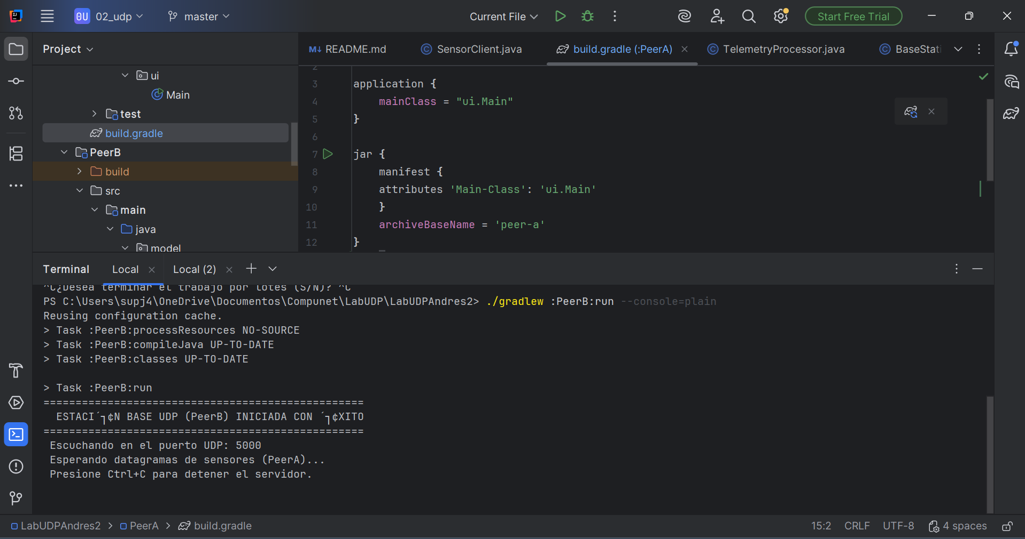

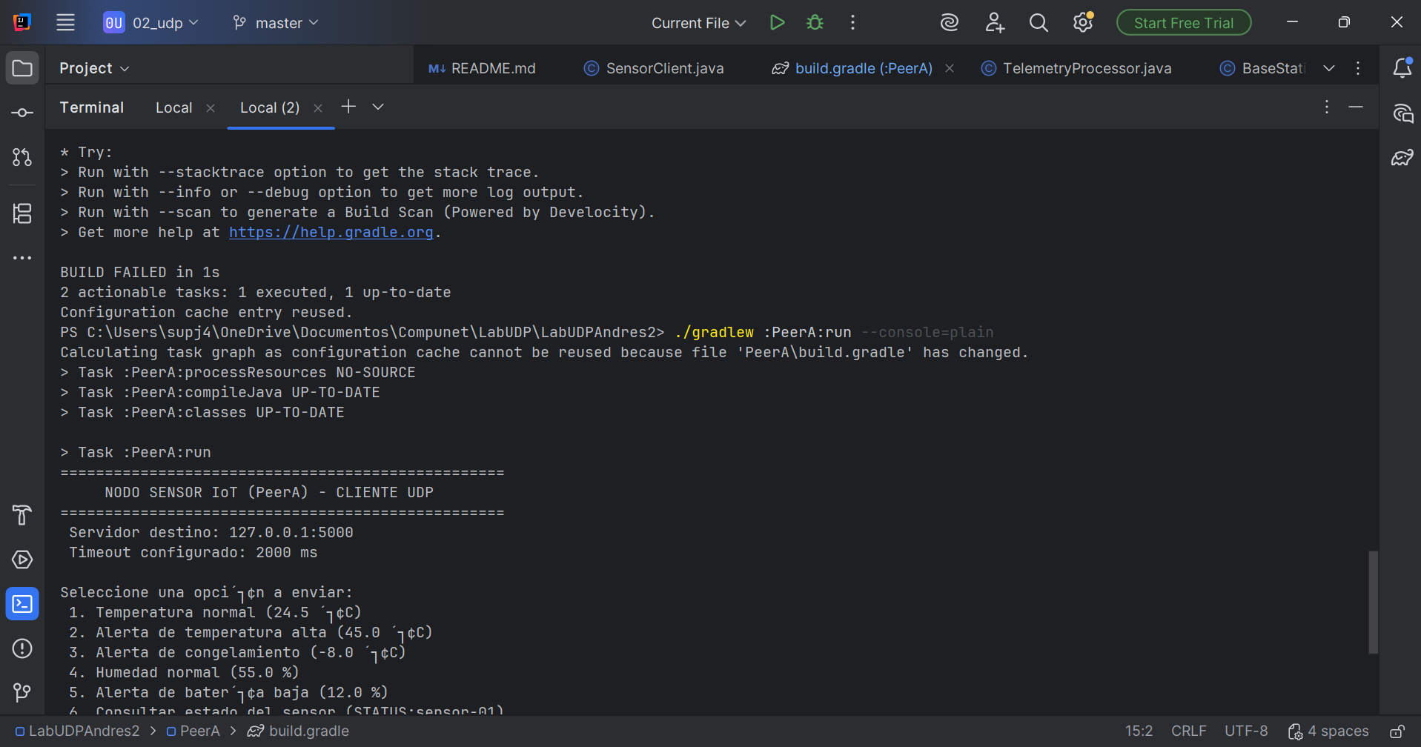
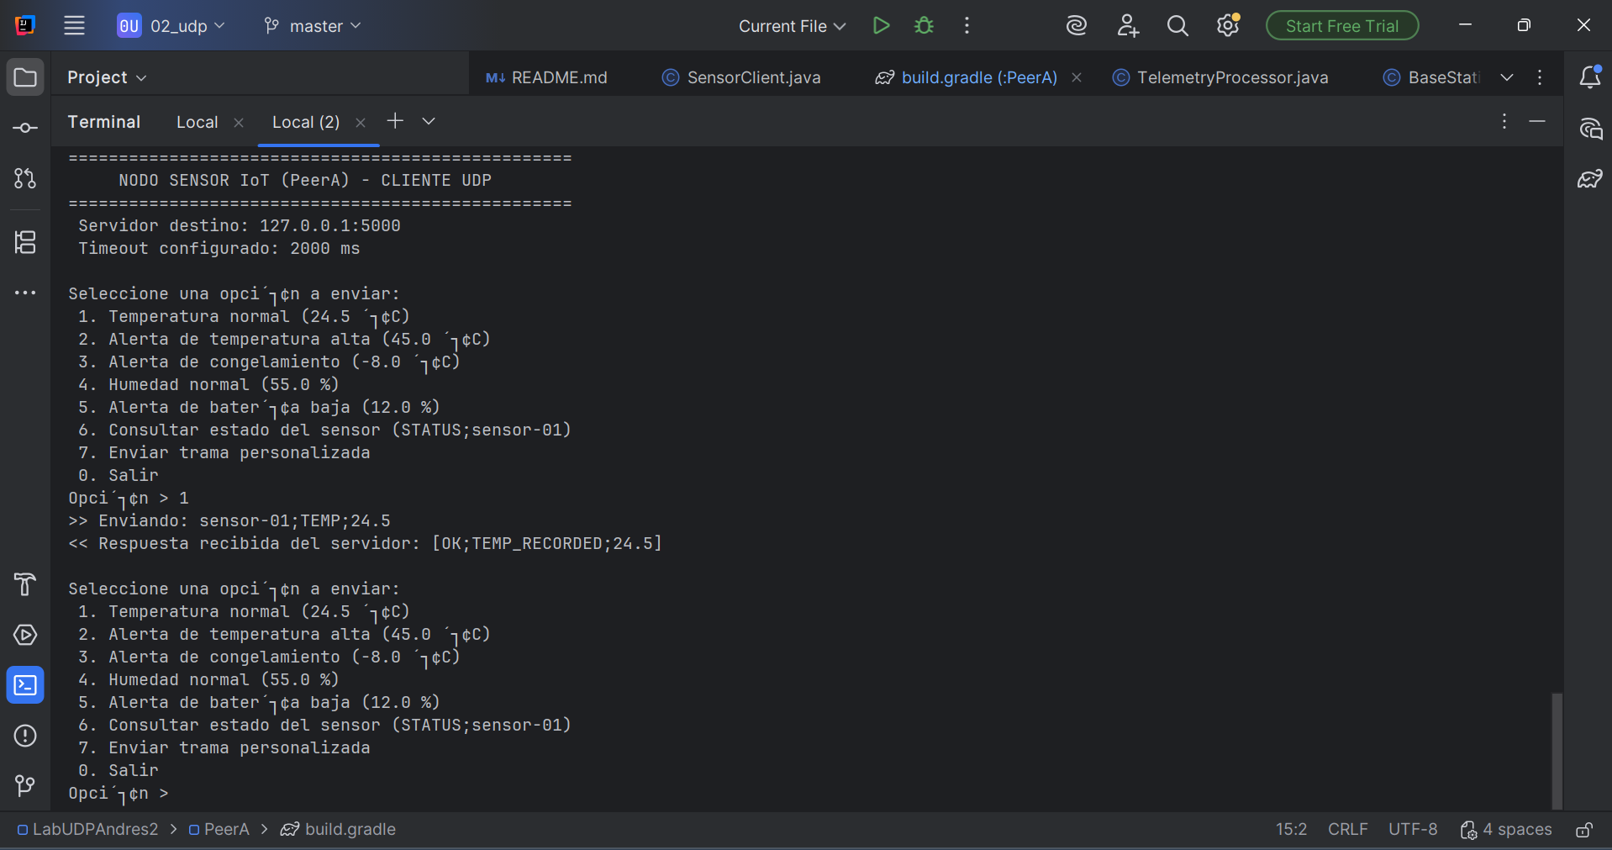

Control+c que pasa:
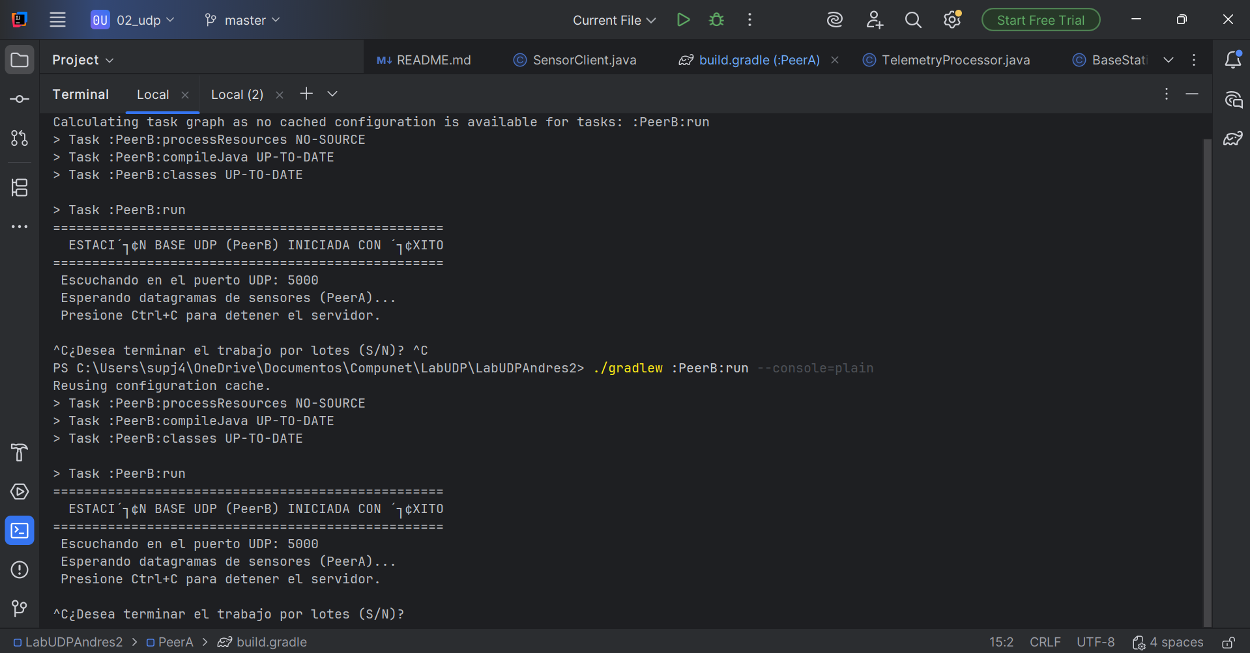

Terminal cliente sigue teniendo su terminal pero la conexión ya se perdió:
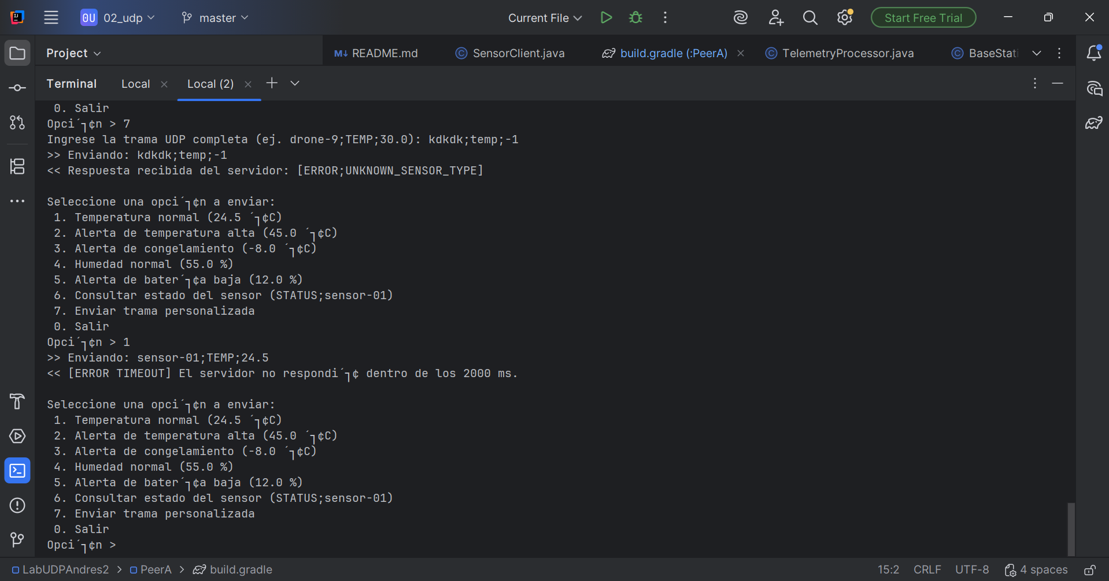

Terminal del NodoSensor cliente:

PS C:\Users\supj4\OneDrive\Documentos\Compunet\LabUDP\LabUDPAndres2> ./gradlew :PeerA:run --console=plain
Calculating task graph as configuration cache cannot be reused because file 'PeerA\build.gradle' has changed.
> Task :PeerA:processResources NO-SOURCE
> Task :PeerA:compileJava UP-TO-DATE
> Task :PeerA:classes UP-TO-DATE

> Task :PeerA:run
==================================================
NODO SENSOR IoT (PeerA) - CLIENTE UDP
==================================================
Servidor destino: 127.0.0.1:5000
Timeout configurado: 2000 ms

Seleccione una opci´┐¢n a enviar:
1. Temperatura normal (24.5 ´┐¢C)
2. Alerta de temperatura alta (45.0 ´┐¢C)
3. Alerta de congelamiento (-8.0 ´┐¢C)
4. Humedad normal (55.0 %)
5. Alerta de bater´┐¢a baja (12.0 %)
6. Consultar estado del sensor (STATUS;sensor-01)
7. Enviar trama personalizada
0. Salir
Opci´┐¢n > 1
>> Enviando: sensor-01;TEMP;24.5
<< Respuesta recibida del servidor: [OK;TEMP_RECORDED;24.5]

Seleccione una opci´┐¢n a enviar:
1. Temperatura normal (24.5 ´┐¢C)
2. Alerta de temperatura alta (45.0 ´┐¢C)
3. Alerta de congelamiento (-8.0 ´┐¢C)
4. Humedad normal (55.0 %)
5. Alerta de bater´┐¢a baja (12.0 %)
6. Consultar estado del sensor (STATUS;sensor-01)
7. Enviar trama personalizada
0. Salir
Opci´┐¢n > 2
>> Enviando: sensor-01;TEMP;45.0
<< Respuesta recibida del servidor: [ALERT;HIGH_TEMPERATURE;45.0]

Seleccione una opci´┐¢n a enviar:
1. Temperatura normal (24.5 ´┐¢C)
2. Alerta de temperatura alta (45.0 ´┐¢C)
3. Alerta de congelamiento (-8.0 ´┐¢C)
4. Humedad normal (55.0 %)
5. Alerta de bater´┐¢a baja (12.0 %)
6. Consultar estado del sensor (STATUS;sensor-01)
7. Enviar trama personalizada
0. Salir
Opci´┐¢n > 3
>> Enviando: sensor-01;TEMP;-8.0
<< Respuesta recibida del servidor: [ALERT;FREEZING_TEMPERATURE;-8.0]

Seleccione una opci´┐¢n a enviar:
1. Temperatura normal (24.5 ´┐¢C)
2. Alerta de temperatura alta (45.0 ´┐¢C)
3. Alerta de congelamiento (-8.0 ´┐¢C)
4. Humedad normal (55.0 %)
5. Alerta de bater´┐¢a baja (12.0 %)
6. Consultar estado del sensor (STATUS;sensor-01)
7. Enviar trama personalizada
0. Salir
Opci´┐¢n > 4
>> Enviando: sensor-01;HUMIDITY;55.0
<< Respuesta recibida del servidor: [OK;HUMIDITY_RECORDED;55.0]

Seleccione una opci´┐¢n a enviar:
1. Temperatura normal (24.5 ´┐¢C)
2. Alerta de temperatura alta (45.0 ´┐¢C)
3. Alerta de congelamiento (-8.0 ´┐¢C)
4. Humedad normal (55.0 %)
5. Alerta de bater´┐¢a baja (12.0 %)
6. Consultar estado del sensor (STATUS;sensor-01)
7. Enviar trama personalizada
0. Salir
Opci´┐¢n > 7
Ingrese la trama UDP completa (ej. drone-9;TEMP;30.0): drone-9;TEMP;46.7
>> Enviando: drone-9;TEMP;46.7
<< Respuesta recibida del servidor: [ALERT;HIGH_TEMPERATURE;46.7]

Seleccione una opci´┐¢n a enviar:
1. Temperatura normal (24.5 ´┐¢C)
2. Alerta de temperatura alta (45.0 ´┐¢C)
3. Alerta de congelamiento (-8.0 ´┐¢C)
4. Humedad normal (55.0 %)
5. Alerta de bater´┐¢a baja (12.0 %)
6. Consultar estado del sensor (STATUS;sensor-01)
7. Enviar trama personalizada
0. Salir
Opci´┐¢n > 7
Ingrese la trama UDP completa (ej. drone-9;TEMP;30.0): kdkdk;temp;-1
>> Enviando: kdkdk;temp;-1
<< Respuesta recibida del servidor: [ERROR;UNKNOWN_SENSOR_TYPE]

Seleccione una opci´┐¢n a enviar:
1. Temperatura normal (24.5 ´┐¢C)
2. Alerta de temperatura alta (45.0 ´┐¢C)
3. Alerta de congelamiento (-8.0 ´┐¢C)
4. Humedad normal (55.0 %)
5. Alerta de bater´┐¢a baja (12.0 %)
6. Consultar estado del sensor (STATUS;sensor-01)
7. Enviar trama personalizada
0. Salir
Opci´┐¢n > 1
>> Enviando: sensor-01;TEMP;24.5
<< [ERROR TIMEOUT] El servidor no respondi´┐¢ dentro de los 2000 ms.

Seleccione una opci´┐¢n a enviar:
1. Temperatura normal (24.5 ´┐¢C)
2. Alerta de temperatura alta (45.0 ´┐¢C)
3. Alerta de congelamiento (-8.0 ´┐¢C)
4. Humedad normal (55.0 %)
5. Alerta de bater´┐¢a baja (12.0 %)
6. Consultar estado del sensor (STATUS;sensor-01)
7. Enviar trama personalizada
0. Salir
Opci´┐¢n > 2
>> Enviando: sensor-01;TEMP;45.0
Seleccione una opci´┐¢n a enviar:
1. Temperatura normal (24.5 ´┐¢C)
<< [ERROR TIMEOUT] El servidor no respondi´┐¢ dentro de los 2000 ms.
2. Alerta de temperatura alta (45.0 ´┐¢C)

3. Alerta de congelamiento (-8.0 ´┐¢C)
4. Humedad normal (55.0 %)
5. Alerta de bater´┐¢a baja (12.0 %)
6. Consultar estado del sensor (STATUS;sensor-01)
7. Enviar trama personalizada
0. Salir
Opci´┐¢n > ^C¿Desea terminar el trabajo por lotes (S/N)? ^C

